ST Visual Programmer - STVP

<https://www.st.com/en/development-tools/stvp-stm32.html>

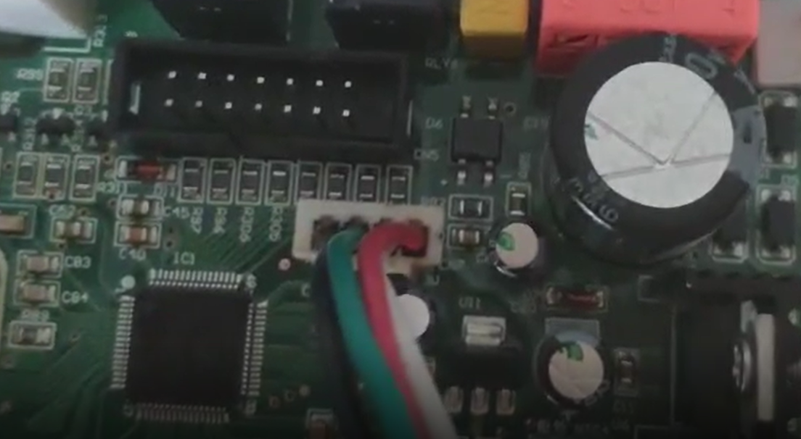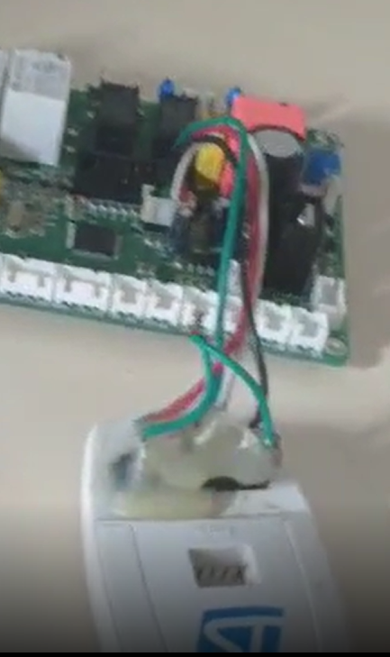**Connector**

1. **Black - GND**
2. **Green - SWCLK**
3. **White - SWDIO**
4. **Red – 3V3**

